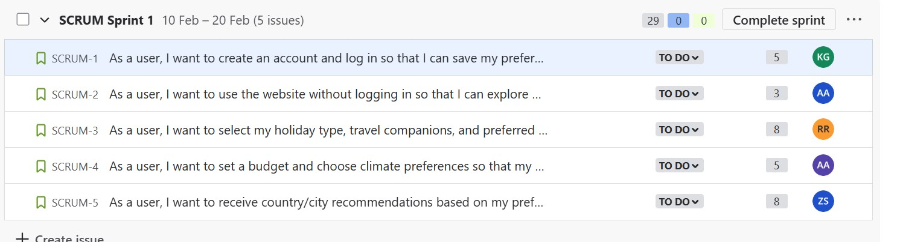

The user stories (in full display):

1. As a user, I want to create an account and log in so that I can save my preferences and access my profile (5 story points) assigned to Khalil Al ghoul.
2. As a user, I want to use the website without logging in so that I can explore options before creating an account (3 story points) assigned to Anas Abdulaziz.
3. As a user, I want to select my holiday type, travel companions, and preferred activities so that I receive personalized recommendations (8 story points) assigned to Rafic Rashidi.
4. As a user, I want to set a budget and choose climate preferences so that my recommendations fit my needs (5 story points) assigned to Anthony Abboud.
5. As a user, I wan to receive country/city recommendation based on my preferences so that I can plan my trip efficiently (8 story points) assigned to Zaed Sarraj.

Tasks:

While working on their respective user stories, the members of this team are required to maintain a minimum level of communication, keep up with knowledge acquirement to make sure they have the tools needed to work, and attend the daily SCRUM meetings that they have come to a consensus on. For the first sprint, the team will have to work hand in hand as they will be creating the website from scratch and need to know what is happening at the base, as the sprints go by, they will gain more independence and freedom to work while, of course, maintaining communication and meeting their goals at the end of each sprint. I, Khalil Alghoul, as the SCRUM master this time around will ensure that my team will follow the Agile methodology and SCRUM framework during this sprint.

The summary of the work to be done in this sprint is: basic website page and login creation, guest mode to check out the features that our website offers, the ability to fully customize the experience and needs by choosing input for budget, travel location, party size and relationship, climate preferences, as well as receiving recommendations and advice based on those preferences.